**F. Y. B. Tech Academic Year 2020-21**

**Trimester: Subject:** Basics of Electrical and Electronics Engineering

**Name ------------------------------ Division ---------**

**Roll No ---------------------------- Batch ----------**

**Experiment No: 8**

**Name of the Experiment**: Finding Resonant Frequency of series R-L-C circuit

**Performed on: -----------------------------------------------**

**Submitted on: -----------------------------------------------**



**Aim : Finding Resonant Frequency of series R-L-C circuit**

**Objective**

To understand the resonance in series R-L-C circuit and to find out resonant frequency of given R-L-C circuit

**Components and equipment required**

| **Components** | **Specifications** |
| --- | --- |
| Signal Generator | Audio frequency range |
| AC Ammeter | 0-1 A |
| R-L-C circuit board | Component values given below |

**Theory**

In the series R-L-C circuit, when inductive reactance $X_{L}$ equals the capacitive reactance $X_{C}$ circuit is called as series resonance circuit. Circuit behaves like a resistive circuit and the resulting current is in phase with the applied voltage. Circuit power factor is unity. At resonance, the equivalent impedance of the circuit consists of only resistive components due to cancelling out the reactive components. At this condition circuit draws the maximum current shown in Fig.4 due to minimum impedance of the circuit as shown in Fig.3. As $X_{L}$ is directly proportional to frequency and $X_{C}$ is inversely proportional to frequency, we can obtain the resonance of any R-L-C circuit by varying its frequency. The frequency, at which this condition occurs, is known as resonance frequency $f_{r}$ of that circuit. The magnitude of the resonating frequency can be calculated using eq.(1)

$f_{r}=\frac{1}{2π\sqrt{LC}}$ (1)

During series resonance, voltage magnification is observed. Voltage across the capacitor or inductor is multiple times the supply voltage. This can be observed using the term Q factor or Quality factor of the circuit which is given by eq. (2)

(2)

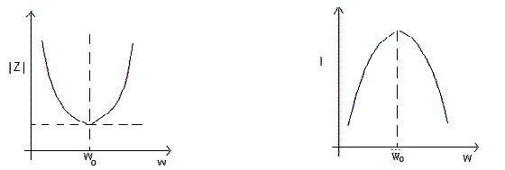

Fig.2: Impedance vs frequency Fig.3: Current vs frequency

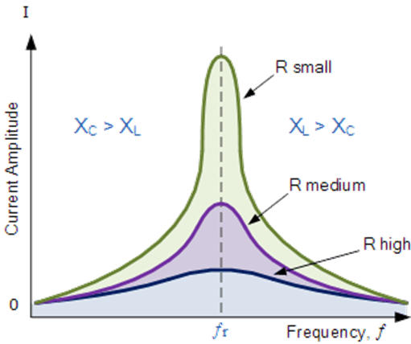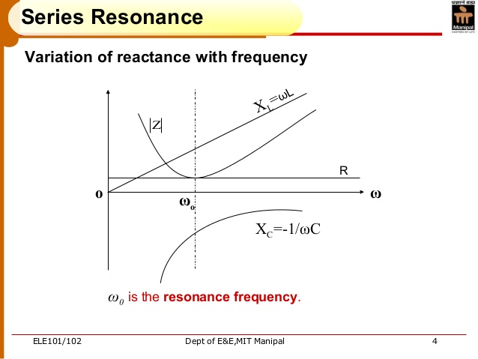

**Procedure**

1. Connect the circuit as shown in Fig.1
2. Give 5V peak to peak amplitude sinusoidal input from the signal generator.
3. Change the frequency and obtain the maximum current in the circuit. Vary frequency from 800 Hz to 2800Hz. Note down this reading at resonant frequency.
4. Adjust frequencies for six equally spaced readings above and below the resonant frequency and note down corresponding current values on AC ammeter.

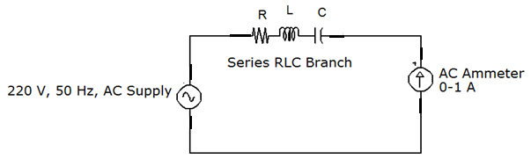

**Fig. 1: Series R-L-C Circuit**

**Observations**

1. **Components used in the series circuit:**
2. $L=$______mH ii) $C=$_______ µF iii) $R=$_______Ω

**Use the components as follows:**

**R= 30 Ohms, L=10 mH, C=1 microF**

1. **Observation Table**

| **Sr. No** | **Frequency (Hz)** | **AC Voltage across R (V)**  **(Proportional to theAC current in the circuit )** |
| --- | --- | --- |
| 1 | 800 |  |
| 2 | 900 |  |
| 3 | 1000 |  |
| 4 | 1100 |  |
| 5 | 1300 |  |
| 6 | 1400 |  |
| 7 | 1500 |  |
| 8 | 1600 |  |
| 9 | 1700 |  |
| 10 | 2000 |  |
| 11 | 2200 |  |
| 12 | 2500 |  |
| 13 | 2800 |  |

**Tinkercad simulation of R_L_C series RESONANT circuit with Voltage across R being observed on oscilloscope.**

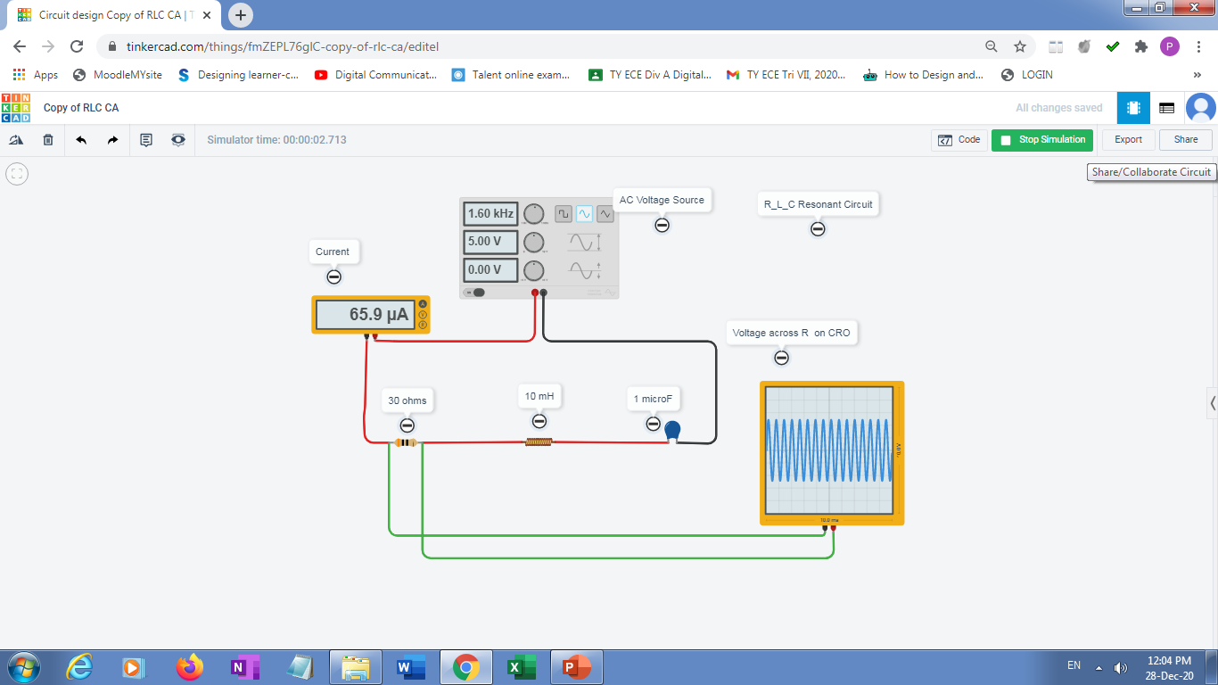

**Graph and Calculations**

1. Plot graph of Current $I$ vs. Frequency $f$
2. Mark resonant frequency $f_{r}$ from the graph.
3. Calculate resonant frequency $f_{r}$ and Q factor using eq.(1) and (2)

**Result:**

|  | **Resonance Frequency (KHz)** |
| --- | --- |
| **Practical Value** |  |
| **Theoretical Value** |  |

**Conclusion: ___________________________________________**

**___________________________________________________________________________**

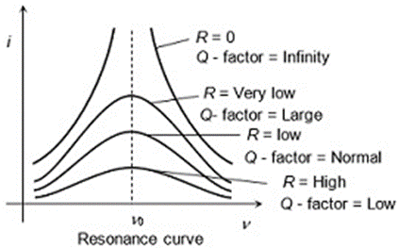

**Post-Lab Questions**

1. Derive the expression for resonance frequency.
2. Explain the reactance curves ( $X_{L}$ vs $f$ and $X_{C}$ vs $f$) for series circuit.
3. Give applications of resonant circuits.

**Note: Students are instructed to do all necessary calculations and answer the questions on separate sheets and attach them.**

**Extra learning resources:**

<https://youtu.be/AUirtqrm-o0>

<https://youtu.be/C8o2UpqzuKI>